
Sign Language Recognition Using Python


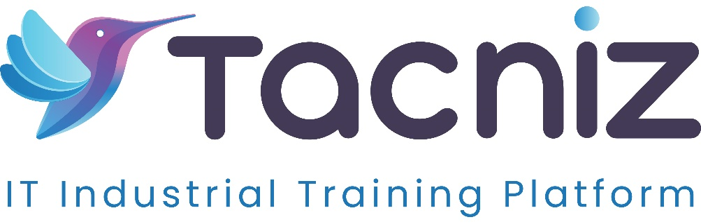
Problem Statement
Communication barriers create challenges for deaf and hard-of-hearing individuals, often resulting in social isolation and difficulties in self-expression. These barriers hinder meaningful interactions, creating a divide between those who use sign language and those who don’t. A sign language recognition system can help bridge this communication gap by interpreting hand gestures into spoken or written language, thus facilitating better communication and fostering inclusivity.
Type
This project is a Computer Vision Application that uses image processing and machine learning techniques to recognize hand gestures and translate them into readable or audible formats, promoting accessibility.
Industry Area
The project is focused on Accessibility and Communication Technology. It has applications in assisting deaf and hard-of-hearing individuals, promoting inclusivity in public and private settings, and aiding in education and therapy.
Software Expertise Required
To develop a sign language recognition system, proficiency in several software tools and libraries is essential:
- Programming Languages: Python, which offers robust libraries for machine learning and computer vision.
- Libraries/Frameworks: Knowledge of OpenCV for image processing, TensorFlow/Keras for building and training Convolutional Neural Network (CNN) models, NumPy for numerical calculations, and Matplotlib for visualizing data during training and testing.
- Development Tools: Familiarity with Jupyter Notebook or other integrated development environments (IDEs) like PyCharm or VSCode for coding, model training, and testing.

Use Cases
- Real-Time Hand Gesture Detection and Recognition: The application detects and interprets hand gestures using a camera, providing a live translation of sign language into text or speech.
- Displaying Corresponding Signs or Text in Real-Time: The recognized sign language gestures are displayed as text or spoken language, allowing seamless communication between sign language users and non-sign language users.
- Model Training with Sign Language Datasets: Using datasets of sign language gestures to train the model, increasing accuracy and expanding the system’s vocabulary of recognized signs.
- User-Friendly Interface: A simple, intuitive interface makes it easy for users to interact with the system, enhancing accessibility and user experience.
Expected Outcomes
The sign language recognition system will improve communication for deaf and hard-of-hearing individuals by translating hand gestures into written or spoken language. This application will raise awareness and understanding of sign language among the general public, contributing to inclusivity. Additionally, it serves as an effective tool for learning sign language, which could support educational and therapeutic initiatives for communication disorders.

Benefits
- Enhanced Communication: Facilitates interaction for deaf and hard-of-hearing individuals, breaking down communication barriers in various social and professional settings.
- Increased Awareness of Sign Language: Encourages the general public to understand and engage with sign language, fostering a more inclusive society.
- Effective Learning Tool: Provides an accessible way for users to learn sign language, which could benefit educators, therapists, and anyone interested in expanding their communication skills.
- Potential for Expanded Applications: The system could be adapted for use in educational institutions, workplaces, healthcare settings, and more, providing value beyond personal communication.
Project Duration
Estimated Duration: 5-6 months, encompassing data collection, model training, and the development of an interactive application, as well as extensive testing to ensure accuracy and usability.

